Final round of loose ends prior to soft launch.. 6/10/17
Screenshot A: minor verbiage change under “Contact Us”
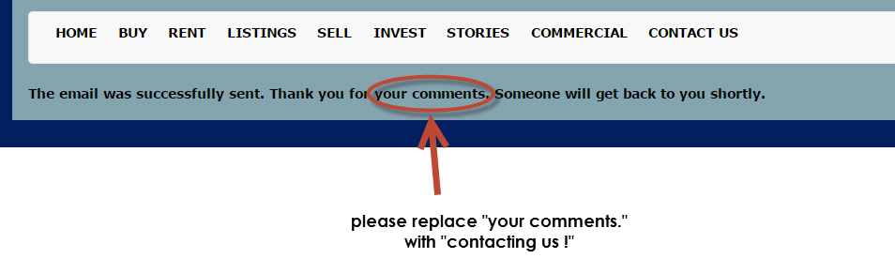
Screenshot B: Eliminate “Sell –“ under “SELL”
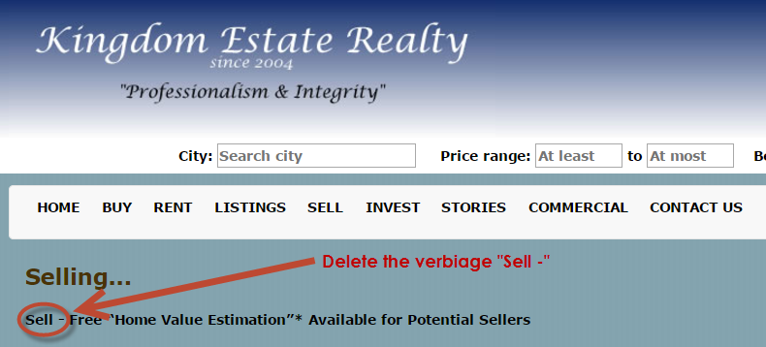

Screenshot C: Make minor clean up, under “Commercial”
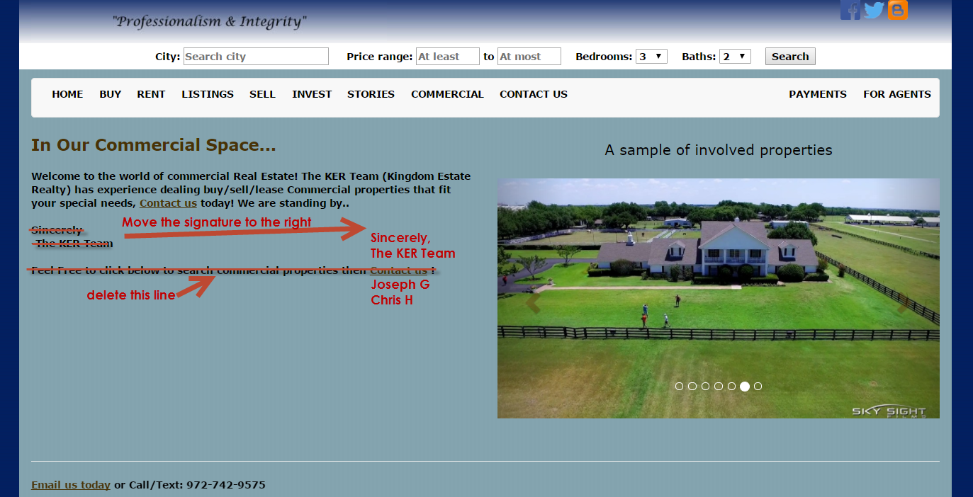

Screenshot D: “Logo” and “Gradient line”, “border” and “highlighting tabs” – these items are all interdepedent. Let me know if that is too hard to do. Thanks!
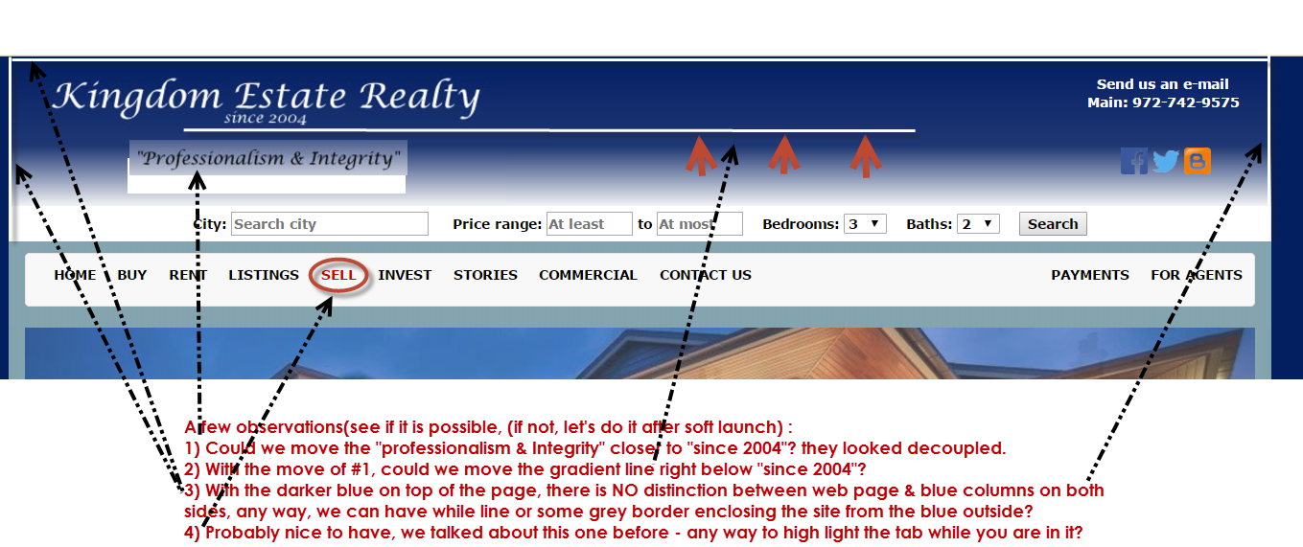

Finally,
Once the above are updated, let’s talk about cut over plan, so that maybe we may be able to kick off the soft launch on Sunday night like 7 - 8 pm or so. Let me know what I need to do to get there.
Thanks for ALL Your Help! I really appreciate your skills and speed in getting my website here so quickly. It looks better and better each day!
-Chris

